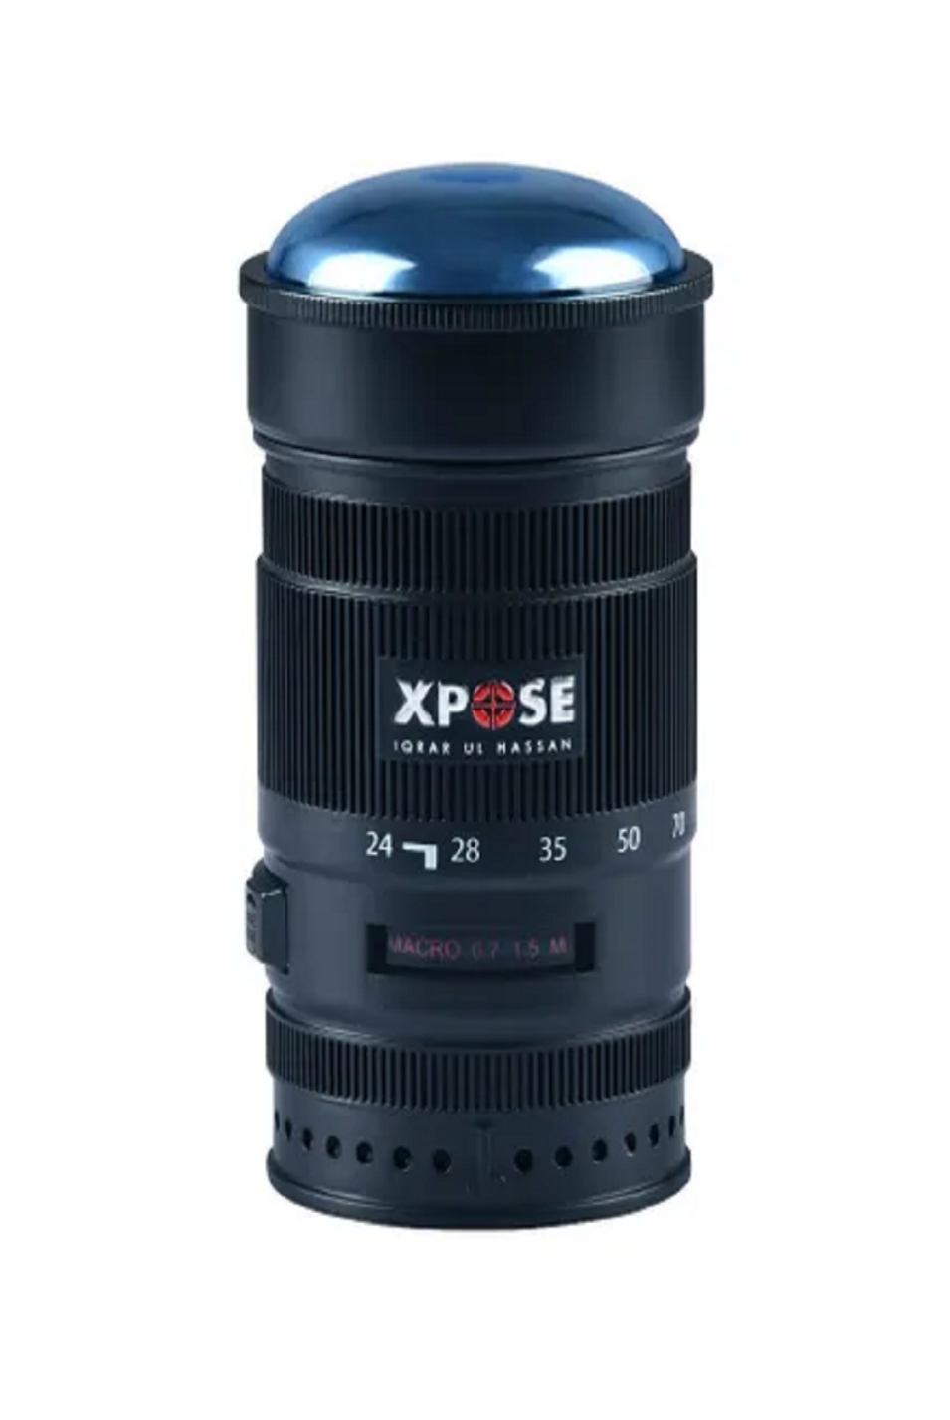

XPOSE

PKR 5,800

Tax Included.

100 mL

IN STOCK

Product Details: